Engineering Design Methods for Instant Film

1. Market Analysis
The global instant film paper market has seen significant growth in recent years, driven by consumer nostalgia, technological advancements, and the growing trend of instant photography. The market size was estimated to be USD 1.65 billion in 2024 and is expected to reach USD 1.9 billion by 2033, growing at a compound annual growth rate (CAGR) of 5.0%[1]. This growth is supported by the increasing appeal of instant film photography in social media culture and at events such as weddings, parties, and festivals.
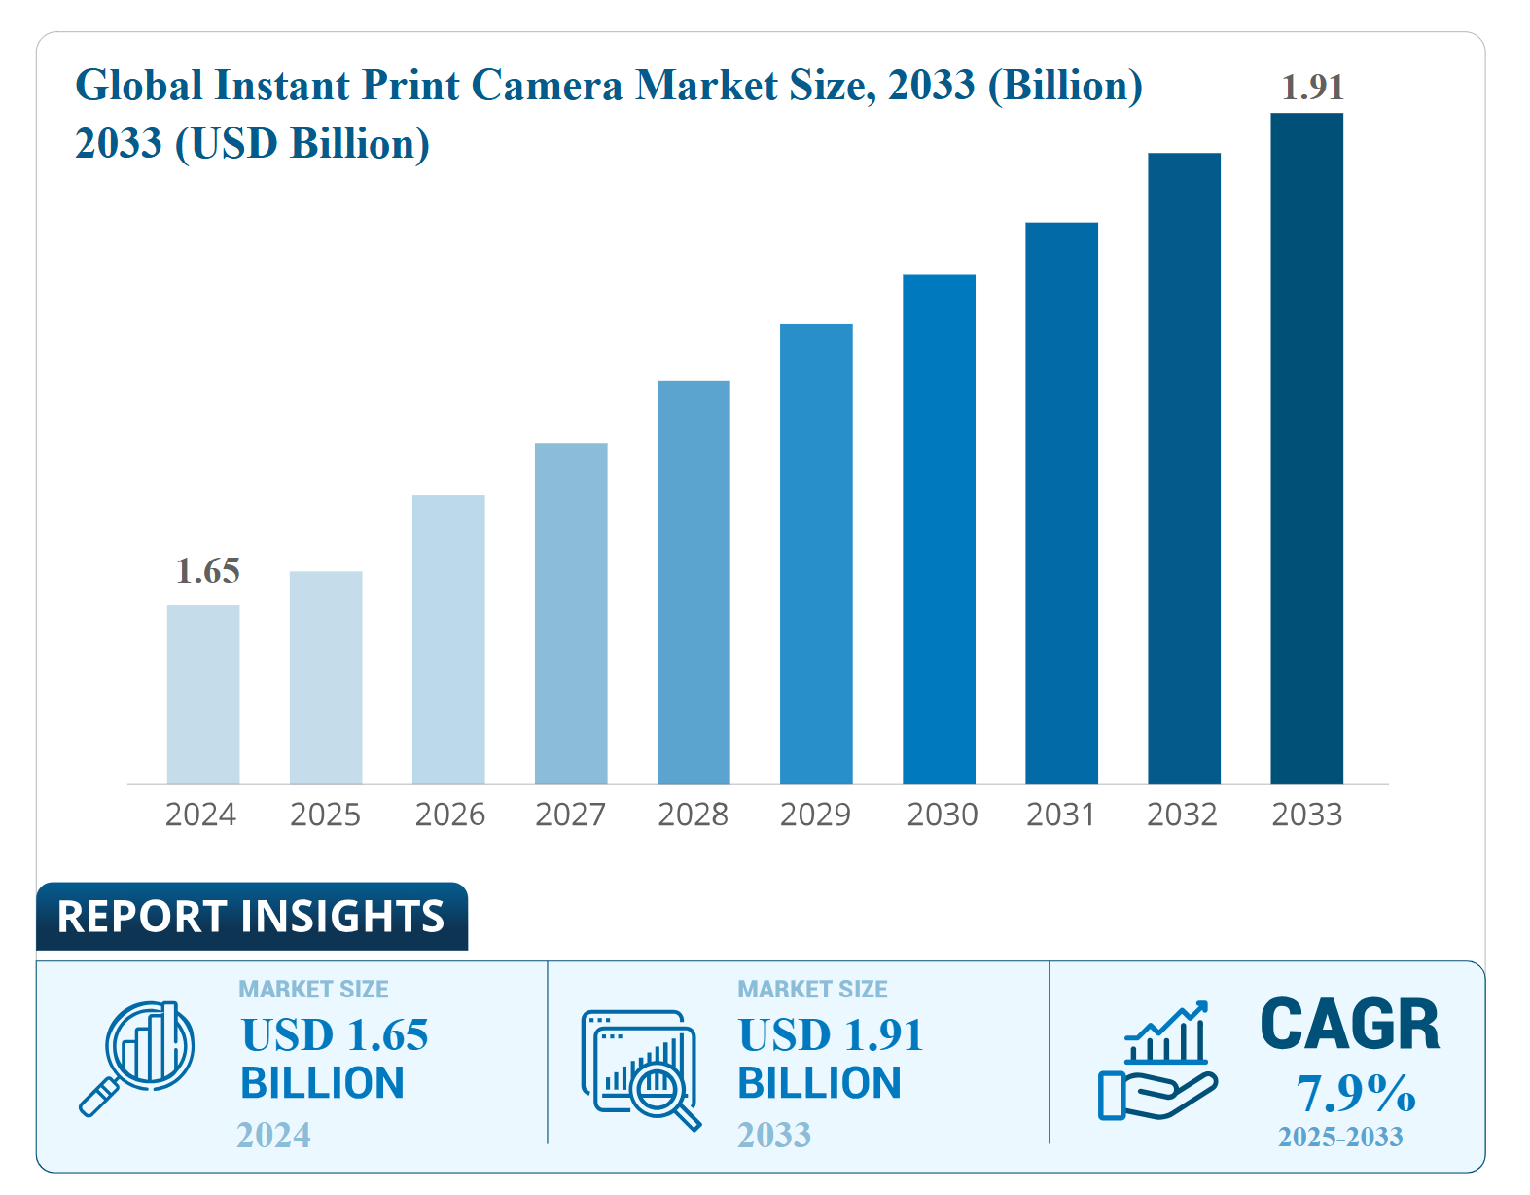
2. Customer Demographics
The primary customers for instant film paper include:
- Youth and Young Adults: Driven by the desire for tangible memories and the popularity of instant photography on social media.
- Professional Photographers: Use instant film for creative projects and test shots.
- Hobbyists: Enjoy the unique experience of instant photography.
- Event Organizers/Businesses: Utilize instant film for promotional and event-based photography 2.
3. Design Features
Instant film paper is designed to produce a visible image within minutes or seconds of exposure. The film contains chemicals needed for developing and fixing the photograph, and the camera initiates the developing process after a photo has been taken key design features include:
- Chemical Composition: Instant film uses chemicals to react to light, producing vibrant and punchy hues.
- Film Sizes: Available in various sizes, including credit card size and mini size 3.
- Ease of Use: Designed for quick and easy photo development without the need for additional settings.
4. Market Demand Trends
The demand for instant film paper is driven by several factors:
- Nostalgia: Consumers seek tangible photographs that evoke a sense of nostalgia.
- Social Media Influence: Instant photos are popular for sharing on social media platforms.
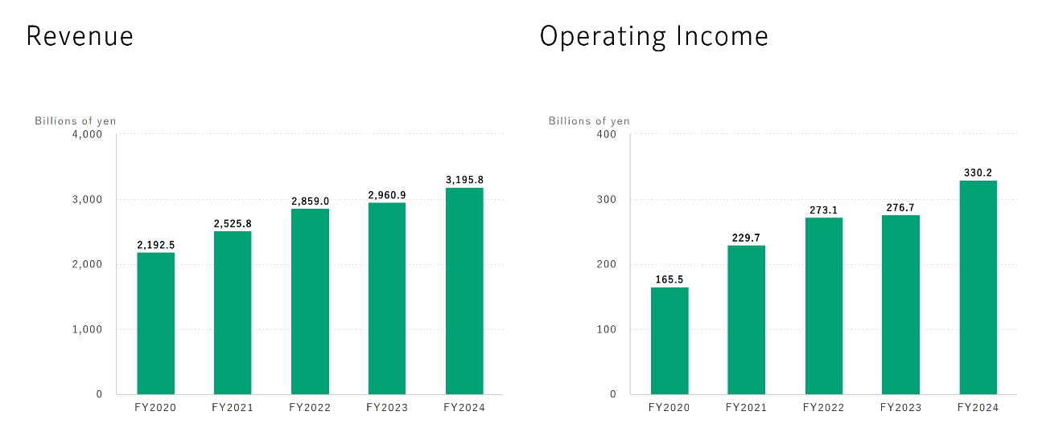
- Event Photography: Instant film is widely used at events like weddings and parties for immediate photo sharing 2.
Chart. Consolidated Financial Results of Fujifilm [4]
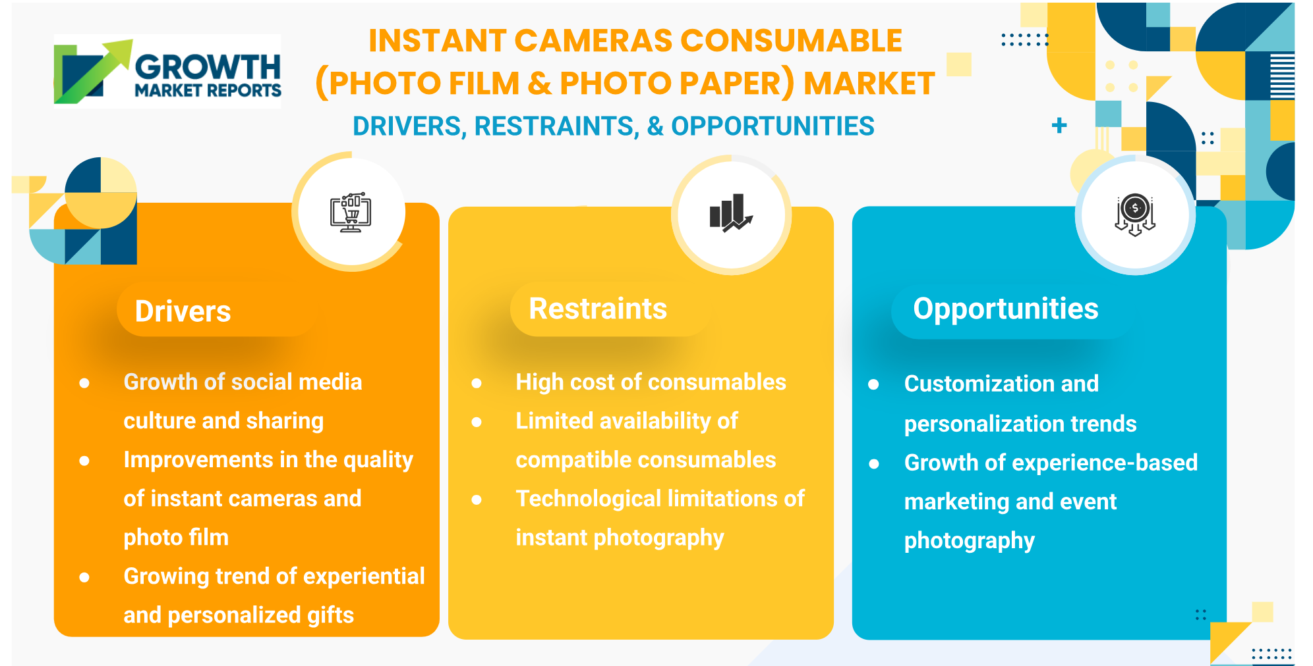
(这张图可以删)
5. User Demand Trends
User demand for instant film paper is influenced by:
- Fashionable Self-Expression: Young people view instant cameras and film as tools for self-expression.
- Tourism: Increased tourism and photo sessions in various locations boost demand 5.
- Creative Industries: Growing usage in creative industries for unique photographic effects 6.
[1] https://pmarketresearch.com/hc/instant-film-cameras-market/
[2] https://growthmarketreports.com/report/instant-cameras-consumable-photo-film-photo-paper-market-size-global-industry-analysis
[3] https://en.wikipedia.org/wiki/Instant_film
[4] https://ir.fujifilm.com/en/investors/performance-and-finance/result1.html
[5] https://www.businessresearchinsights.com/market-reports/instant-print-camera-market-101618
[6] https://dataintelo.com/report/global-instant-films-market

https://pmarketresearch.com/hc/instant-film-cameras-market/
https://www.fujifilm.com.cn/cn/zh-hans/news/detail/3880
https://instax.fujifilm.com.cn/brand-history.html#v-pills-messages

